**The Application of AI in Human Trafficking**

**Abstract**

Human traffickers have begun to develop new and creative uses for Artificial Intelligence, changing the way they operate. The United States government has been using the same technologies to identify trafficking patterns, victims, and perpetrators. However, this technology comes with significant legal and ethical decisions that must be made by the United States government

**Statement of the Issue**

The accessibility of Artificial Intelligence has led to drastic developments in how traffickers communicate with one another, buyers, and victims; and how they maintain control of their enterprises. When using similar technology, the United States government must consider the risk of machine bias, unintentional Constitutional violations, and the very real possibility that those traffickers identified abroad may never be convicted for their crimes.

**Background**

The [13th Amendment](https://constitution.congress.gov/constitution/amendment-13/) of the Constitution bans slavery and involuntary servitude with the notable exception being as punishment after being duly convicted of a crime.[1] The United States Constitution thus explicitly bans slavery within its jurisdiction. Still, it leaves open the question of what it means to be a “slave” or “involuntary servant”, as it was not the framers’ intention at the time of drafting that it be applied to all forms of [Modern Slavery](https://sociology.columbian.gwu.edu/sites/g/files/zaxdzs5541/files/2023-02/trafficking_-_great_decisions_r._weitzer.pdf) such as Human Trafficking.[2] Recognizing the deficiency, [Congress](https://www.justice.gov/humantrafficking/key-legislation) has enacted a handful of laws to identify these modern forms of slavery, provide victim protections, and authorize efforts to prevent further trafficking of persons.[3] However, this effort has been met with complications. For one, there have been ongoing efforts by Federal and State legislators to define Human Trafficking victims. How they define these victims determines whether they may access public benefits, receive protection from deportation, or qualify for temporary nonimmigrant status with an opportunity for permanent residence after three years continued presence. A primary example of this ongoing effort is the Trafficking Victims Protection Act (TVPA), which was originally created in 2000, has been amended several times, the most recent amendment being made in August of 2024. A common theme to these amendments has been the struggle to identify all variations of trafficking, as trafficking has become a spiderweb of nefarious activities as opposed to the traditional use of force, fraud, or coercion. As society evolves, there have been and continue to be new and unusual methods of human trafficking and how traffickers reach their victims. This lack of comprehensive United States laws penalizing the full range of trafficking offenses means traffickers often escape deserved punishment even after capture.[4] Further, in a case where the Supreme Court considered international human rights norms, particularly those which prohibit acts such as genocide, torture, and slavery, the United States conceded that although such perpetrators are "enemies of all mankind", there are still significant barriers to holding such perpetrators accountable when they are outside the United States.[5]

Webster’s Dictionary uses the following definition for Human Trafficking; “organized criminal activity in which human beings are treated as [possessions](https://www.merriam-webster.com/dictionary/human%20trafficking) to be controlled and exploited (as by being forced into sex work or involuntary labor).”[6] The [Council on Foreign Relations](https://education.cfr.org/learn/reading/human-trafficking-global-era), a think tank, has a slightly different definition to consider; “Human trafficking is the trapping and exploitation of a person using deception, violence, or coercion. It generally takes three main forms: forced labor (which includes sex trafficking), forced marriage, and forced organ removal.”[7]

Human trafficking encompasses far more than the average person realizes. Although it may not have been intended by those who developed the technology, Artificial Intelligence has become yet another “possession” at the hands of these organizations. Below are two tables explaining the various forms of “modern slavery” and an estimated 20.8 million being illegally trafficked for labor and sex in [2016](https://www.ilo.org/sites/default/files/wcmsp5/groups/public/@dgreports/@dcomm/documents/publication/wcms_575479.pdf).[8] Further, in [2024](https://www.state.gov/reports/2024-trafficking-in-persons-report/), the Secretary of State estimated that 27 million people around the world were exploited for labor, services, and commercial sex through the use of force, fraud, or coercion.[9]

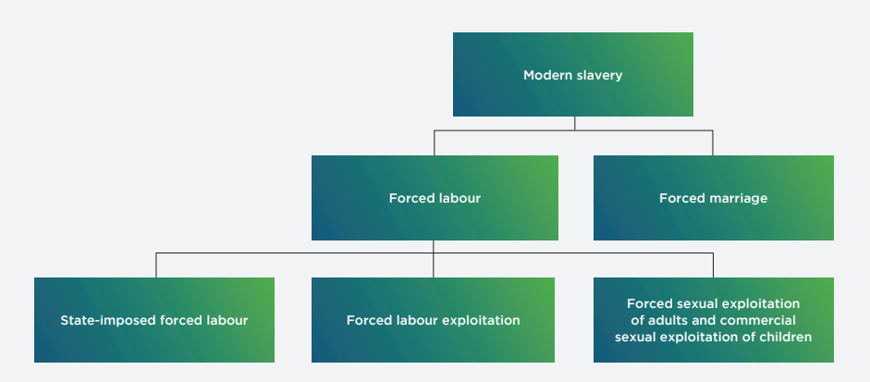

*Source:* [ILO.](https://www.ilo.org/wcmsp5/groups/public/@dgreports/@dcomm/documents/publication/wcms_575479.pdf) Get the data

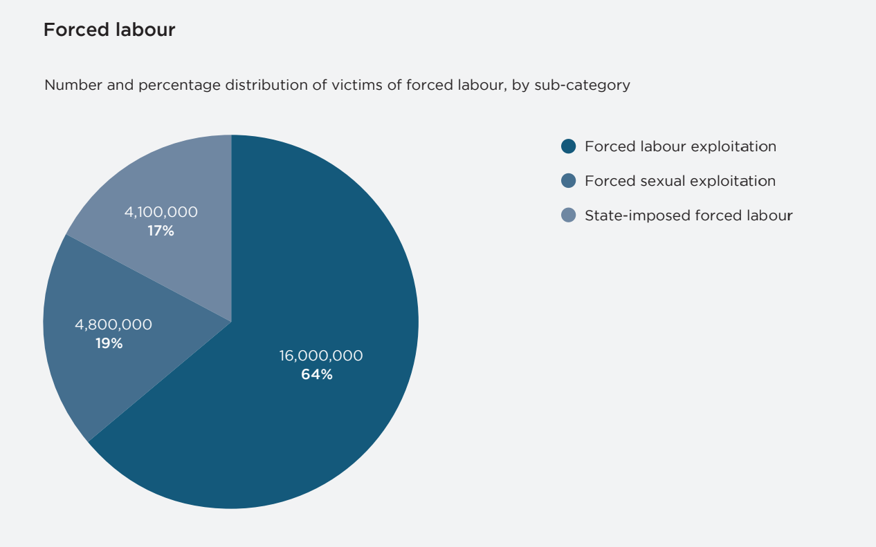

*Source:* [ILO.](https://www.ilo.org/wcmsp5/groups/public/@dgreports/@dcomm/documents/publication/wcms_575479.pdf) Get the data

**Human Traffickers’ Use of AI**

**Communication**

In a human trafficking ring, AI is used to communicate between three key “players”, if you will. The roles of these players consist of 1) sellers; 2) buyers; and 3) victims.

**Sellers & Buyers**

For one, Learning Language Models (LLMs) have simplified international trafficking recruitment efforts. Through LLMs, traffickers can now [communicate](https://www.afcea.org/signal-media/cyber-edge/technologys-good-and-evil-fueling-and-fighting-human-trafficking) with one another, regardless of where they live or what language they speak. This allows traffickers to recruit, reach buyers, and sell victims without fear of there being a language barrier.[10] Many [recent LLMs](https://arxiv.org/html/2404.02323v1) have proven successful in the ability to pick up and replicate the use of slang and other informal language, allowing seamless communication no matter the variation in location, education, age, etc.[11]

Buyers and sellers alike use sophisticated technology throughout the transaction process. Each ring of traffickers has developed codes and [keywords or phrases](https://www.afcea.org/signal-media/cyber-edge/technologys-good-and-evil-fueling-and-fighting-human-trafficking) so that they may be found by buyers via the internet or telephone without being flagged by authorities.[12] Similarly, traffickers have identified ways of placing and accepting bid offers and quotes using language that would not ordinarily be picked up by AI or humans screening for the use of words more commonly used in the modern slave trade.

**Victims**

Machine learning allows AI to identify patterns. For instance, AI technologies can be used to identify who a victim may be likely to find approachable or attractive by searching for [patterns](https://www.osce.org/files/f/documents/7/d/579715.pdf) in search engine history, dating history, online friend groups, etc. and it has become just as easy to create a profile of a potential friend or love interest with the same interests, hobbies, and non-threatening presence with the aid of AI.[13] Alternatively, traffickers may use generative AI to give the victim the impression they are closer to the victim, or in more control of the victim, than they are. It is suspected that the use of AI in deceiving and coercing victims of trafficking is the [most common](https://www.osce.org/files/f/documents/7/d/579715.pdf) use of Generative AI by the perpetrators.[14]

Victims who openly use social media apps often don’t consider the [consequences](https://news.un.org/en/story/2021/10/1104392) when broadcasting their location to “friends” who share the app.[15] Traffickers have used apps and websites with this feature to locate victims. All they need to do is create a profile with the help of artificial intelligence or perhaps impersonate someone the victim believes they already know. “Deep Fake” images make it easy to generate images and audio of individuals victims may believe to be friends, family, prior classmates, etc. Further, LLMs can translate and mimic “tones” of conversation to navigate social cues, making the fraudster more convincing despite not knowing the language. For example, AI can change the tone of a message so that it is casual, persuasive, assertive, coercive, etc.

**Control**

With AI technology, it’s never been easier for the key players in a human trafficking ring to control their organization. With long-distance, real-time communications between traffickers and those in actual, physical possession of their victims, traffickers are now able to maintain constructive possession, defined as the exercise of dominion and control, over their victims, even from across the world. Further, with surveillance technologies an escape from trafficker’s control has never been more difficult. Many survivors report being constantly [surveilled](https://osce.usmission.gov/taking-a-lesson-from-traffickers-harnessing-technology-to-further-the-anti-trafficking-movement/), especially while being forced to work, as a form of coercion meant to keep victims from leaving or asking for help from the unsuspecting public.[16] Alternatively, these surveillance technologies have led to victims becoming subjects of live, [broadcasted](https://www.investigatewest.org/investigatewest-reports/a-washington-teen-was-trafficked-by-a-man-she-met-on-tinder-she-says-two-years-later-shes-still-waiting-for-justice-17706687) pornography fed directly to buyers, or as blackmail after performing consensual sex acts with their trafficker.[17]

**Government Considerations**

Given that these techniques are understood and just as available to United States authorities, one may wonder how traffickers could be more active now than ever. In part, this comes down to ever-changing trafficking strategies, AI bias and other weaknesses, Constitutional limitations, and International Law hurdles in justiciability. Perhaps the most significant issue, however, is the accessibility of AI and the difficulty policymakers are facing with its regulation both international and domestic. There are many AI models out there that can be downloaded to a computer free of charge and a significant number more that can be purchased for a fee.[18] Advanced models that can still be operated on something as unsuspecting as a high-end laptop are particularly difficult to track because of their mobility and commonality among the public.[19]

“Deep Thinking” [machine learning](https://khalpey-ai.com/how-artificial-intelligence-can-help-stop-human-and-organ-trafficking/#:~:text=Furthermore%2C%20machine%20learning%20algorithms%20can,identify%20potential%20victims%20and%20traffickers), a combination of multiple layers of supervised learning, unsupervised learning, and reinforcement learning, gives Artificial Intelligence its ability to adapt by changing the weights of variables pre-programmed and later identified as relevant due to its pattern recognition capabilities.[20] This technology has been helpful in the fight against terrorism, but just like the humans who created it, it's far from perfect. Although there are great benefits to using the same AI technologies used by traffickers, there are also significant downsides.

First, from their inception, these algorithms house the bias of their creators and the data that’s been inputted into the systems machine learning utilizes. Machine Learning picks up patterns, even unintended ones such as the ethnicity or gender of those traffickers already charged with trafficking. In [2021](https://bjs.ojp.gov/library/publications/human-trafficking-data-collection-activities-2023), 72% of defendants charged with peonage, slavery, forced labor, and sex trafficking were men while 58% of those defendants were African American.[21] As a result, the algorithm will be “biased” when the individuals under scrutiny are African American and/or male since it will consider these factors as just another part of the pattern. Similarly, 92% of defendants charged in federal court for “[human trafficking offenses](https://bjs.ojp.gov/library/publications/human-trafficking-data-collection-activities-2023)” were male and 60% were white.[22] As such, the algorithm will consider this data as part of the “patterns” used to identify human trafficking offenses and suspected traffickers. If these identified trafficking patterns are not verified by humans, there is significant risk of the algorithm “barking up the wrong tree”, so to speak, as it will not know if the patterns it finds are human trafficking or not. Rather, it may well become overly familiar with a certain shipping company, simply because the algorithm deemed the mannerisms on board and racial profiles of the crew to be consistent with previously identified traffickers. When this happens, and the result is relied on as-is, without human verification, it is entirely possible that the shipping company and its crew will be falsely accused or even arrested for human trafficking. In this scenario, at best the AI’s bias has wasted time and resources, at worst, innocent people may be convicted.

Second, AI is a machine and thus incapable of considering morals, ethics, and the significance of Constitutional rights granted to citizens and those who come within the territory of the United States and develop substantial connections therein.[23] These significant connections are to be considered on a case-by-case basis, by human review of the totality of the circumstances.[24] AI, on the other hand, requires comparative data to identify potential traffickers and a clear order identifying what data does and does not belong to constitutionally protected individuals. This can include anything from satellite data of [shipping routes](https://globalfishingwatch.org/press-release/forced_labor_risk_fishing/)[25] to data consensually given to [third-party](https://supreme.justia.com/cases/federal/us/442/735/)[26] service providers, to details obtained in routine border searches and other [special needs](https://constitution.congress.gov/browse/essay/amdt4-6-6-3/ALDE_00000239/)[27] exceptions deemed necessary to meet the special needs of the government to search and seize [without a warrant](https://www.ojp.gov/ncjrs/virtual-library/abstracts/special-needs-exception-warrant-requirement)[28] or probable cause. It is unlikely AI will ever be able to consider circumstances such as moral and ethical considerations as to whether a non-citizen or citizen abroad is protected by the Constitution.[29] For example, it is conceivable that AI could be programmed to avoid collecting data on those registered in “REAL ID”, a Federal ID database that only includes those legally residing in the United States. But what about those who are undocumented or do not possess a REAL ID or other documentation that could be collected by AI? The Fourth Amendment explicitly protects the right of the people to be secure in their persons, houses, papers, and effects, against unreasonable searches and seizures without a warrant or probable cause.[30] Prior to identifying whether or not a person is a citizen or otherwise protected non-citizen, AI will not be able to stop collecting data on what it otherwise perceives to be suspicious conduct for unverifiable reasons. Were the individuals who later turned out to be U.S. Citizens on an Oceanic Voyage with family and friends flagged as traffickers because they were outside of the United States and of a specific color? Did it have to do with what kind of vessel they were on? The movements onboard? There are countless variables with AI and the weight given to each variable is unknown to even the engineers who design the algorithm. It would be easy for AI to mistakenly record and flag footage of an American family enjoying their voyage just as easy as it would be for AI to record and flag footage of Human Traffickers aboard the same vessel, of the same skin color, traveling the same route, etc. Doing so is, however, a violation of one’s Fourth Amendment right, and even if guilty of trafficking in persons, citizens could use that Fourth Amendment violation to suppress this AI-collected information which may not only permit a trafficker to get away with their crimes but would also alert this individual and those within the same “network” of this information, allowing them to evade detection after becoming privy to the factors considered by AI satellite surveillance.

A third major concern is International Law hurdles, such as an inability to hold traffickers [accountable](https://www.justice.gov/jm/jm-9-15000-international-extradition-and-related-matters#9-15.650) when they are non-extraditable, foreign law enforcement is uncooperative, or doing so would simply be too time-consuming and costly.[31] International Law provides that each state is to be its own sovereignty and thus, has the authority to govern its own territory and people.[32] This includes a nation’s right to determine how and when they will provide recourse for acts that violate international standards.[33] For example, as was the issue in *Jesner v. Arab Bank, PLC*, absent an agreement with foreign sovereignties to hold human traffickers accountable, the United States government may not hold foreign entities accountable for human trafficking discovered in the United States. Similarly, if the victim of human trafficking has never been to the United States and has no other significant ties to the country, they are not protected by the Constitution and as such, the United States has no authority to intervene. The principles of International Law provide that each state is its own Supreme Power and controls that which is within its jurisdiction. Further, the principles of International Law require states to respect one another, regardless of their size or power. To intervene absent an invitation or in the exercise of a state’s right to protect itself and its citizens would be a direct violation of these customary principles.

**Conclusion**

In conclusion, traffickers are using Artificial Intelligence as a means of communication and exercise of control over their organizations. Despite having access to this same technology, the United States government is restricted in how and when it can be used to combat Human Trafficking. Moving forward, policymakers should be careful to consider the limitations and weaknesses of AI, Constitutional rights, and International Law challenges regarding human rights and accountability of identified perpetrators located outside the United States.

1. U.S. Const. amend. XII, at <https://constitution.congress.gov/constitution/amendment-13/>
2. Ronald Weitzer, Modern slavery and human trafficking, Feb. 2023, at <https://sociology.columbian.gwu.edu/sites/g/files/zaxdzs5541/files/2023-02/trafficking_-_great_decisions_r._weitzer.pdf>
3. U.S. Dep't of Justice, *Key Legislation*, Aug. 23, 2023, at <https://www.justice.gov/humantrafficking/key-legislation>
4. 22 U.S.C.A. § 7101
5. *Jesner v. Arab Bank*, PLC, 584 U.S. 241 (2018).
6. Merriam-Webster, *Human trafficking*, (n.d.), at <https://www.merriam-webster.com/dictionary/human%20trafficking>
7. Council on Foreign Relations, Human Trafficking in the Global Era, Dec. 21, 2020, at <https://education.cfr.org/learn/reading/human-trafficking-global-era>
8. Int. Labour Org., *Global estimates of modern slavery: Forced labour and forced marriage*, 2017, at <https://www.ilo.org/sites/default/files/wcmsp5/groups/public/@dgreports/@dcomm/documents/publication/wcms_575479.pdf>
9. U.S. Dep’t. of State, *Trafficking in Persons Report*, Jun. 2024, at <https://www.state.gov/wp-content/uploads/2025/02/TIP-Report-2024_Introduction_V10_508-accessible_2.13.2025.pdf>
10. Diego Laje and Nuray Taylor, *Technology’s Good and Evil: Fueling and Fighting Human Trafficking*, Nov. 1, 2023, at <https://www.afcea.org/signal-media/cyber-edge/technologys-good-and-evil-fueling-and-fighting-human-trafficking>
11. Yang Xu et al.,  *Toward Informal Language Processing: Knowledge of Slang in Large Language Model*s, Apr. 2, 2024, at <https://arxiv.org/html/2404.02323v1>
12. Laje, supra.
13. OSCE, *New Frontiers: The use of Generative Artificial Intelligence to Facilitate Trafficking in Persons*, Nov. 2024, at <https://www.osce.org/files/f/documents/7/d/579715.pdf>
14. OSCE, *supra*.
15. U.N. News, *Traffickers abusing online technology, UN crime prevention agency warns*, Oct. 30, 2021, at <https://news.un.org/en/story/2021/10/1104392>
16. OSCE, *Taking a Lesson From Traffickers: Harnessing Technology To Further the Anti-Trafficking Movement’s Principal Goals*, Apr. 8, 2019, at <https://osce.usmission.gov/taking-a-lesson-from-traffickers-harnessing-technology-to-further-the-anti-trafficking-movement/>
17. [Kelsey Turner](https://www.investigatewest.org/author/kelsey-turner), *A Washington teen was trafficked by a man she met on Tinder, she says. Two years later, she’s still waiting for justice.*, Jul. 25, 2024, at <https://www.investigatewest.org/investigatewest-reports/a-washington-teen-was-trafficked-by-a-man-she-met-on-tinder-she-says-two-years-later-shes-still-waiting-for-justice-17706687>
18. OSCE, *supra*.
19. *Id*.
20. Khalpey et al., *How Artificial Intelligence Can Help Stop Human and Organ Trafficking*, (n.d.), at <https://khalpey-ai.com/how-artificial-intelligence-can-help-stop-human-and-organ-trafficking/#:~:text=Furthermore%2C%20machine%20learning%20algorithms%20can,identify%20potential%20victims%20and%20traffickers>
21. U.S. Dep’t. of Just., *Human Trafficking Data Collection Activities*, Oct. 2023, at <https://bjs.ojp.gov/document/htdca23.pdf>
22. *Id*.
23. Stephen Dycus, William C. Banks, Emily Berman, Peter Raven-Hansen, Stephen I. Vladeck, *National Security Law* 220 (8th ed. 2024).
24. *Id*.
25. Sarah Bladen, *Satellites can reveal risk of forced labor in the world’s fishing fleet*, Dec. 21, 2020, at <https://globalfishingwatch.org/press-release/forced_labor_risk_fishing/>
26. *Smith v. Maryland*, 442 U.S. 735 (1979)
27. U.S. Const. amend. IV § 6.6, (n.d.), at <https://constitution.congress.gov/browse/amendment-4/?anchor=4_6_6#4_6_6>
28. Martin J. King J.D., *"Special Needs" Exception to the Warrant Requirement*, Jun. 2006, at <https://www.ojp.gov/ncjrs/virtual-library/abstracts/special-needs-exception-warrant-requirement>
29. Dycus et al., *supra*.
30. U.S. Const. amend. IV.
31. U.S. Attorneys' Manual, *Title 9: Criminal, 9-15.000 - International Extradition And Related Matters*, (n.d.), at <https://www.justice.gov/jm/jm-9-15000-international-extradition-and-related-matters#9-15.650>
32. U.S. Attorneys' Manual, *supra*.
33. *Id*.